A picture containing clipart

Description generated with very high confidence

Hands-on

Creating a Lustre File system and mounting it

AWS Solutions Architect

[**support@intellipaat.com**](mailto:support@intellipaat.com)

**+91-7022374614**

**US: 1-800-216-8930(Toll Free)**

**Creating a Lustre File system and mounting it**

**Step 1:** Launch an Amazon Linux 2 instance with a custom TCP rule of port 988 open

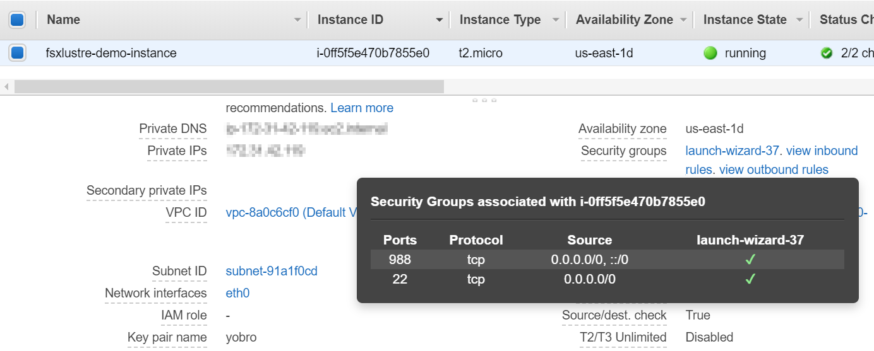

**Step 2:** Click on Create File System to start the process

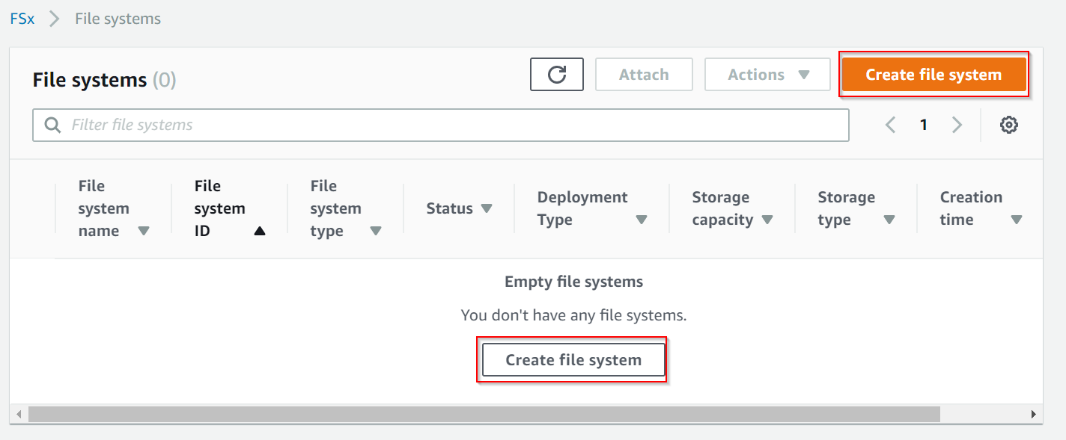

**Step 3:** Then choose FSx for Lustre, then go down and click Next button

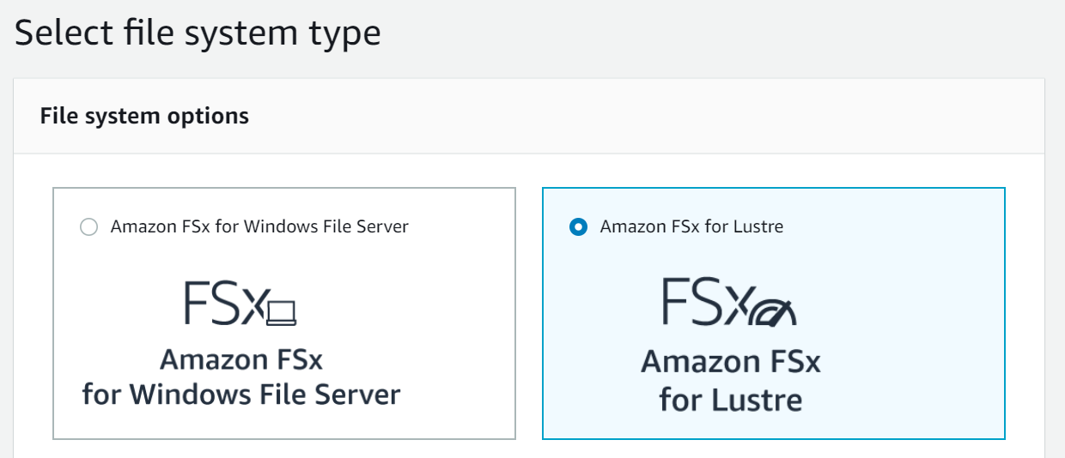

**Step 4:** Then put in the details to create a File system

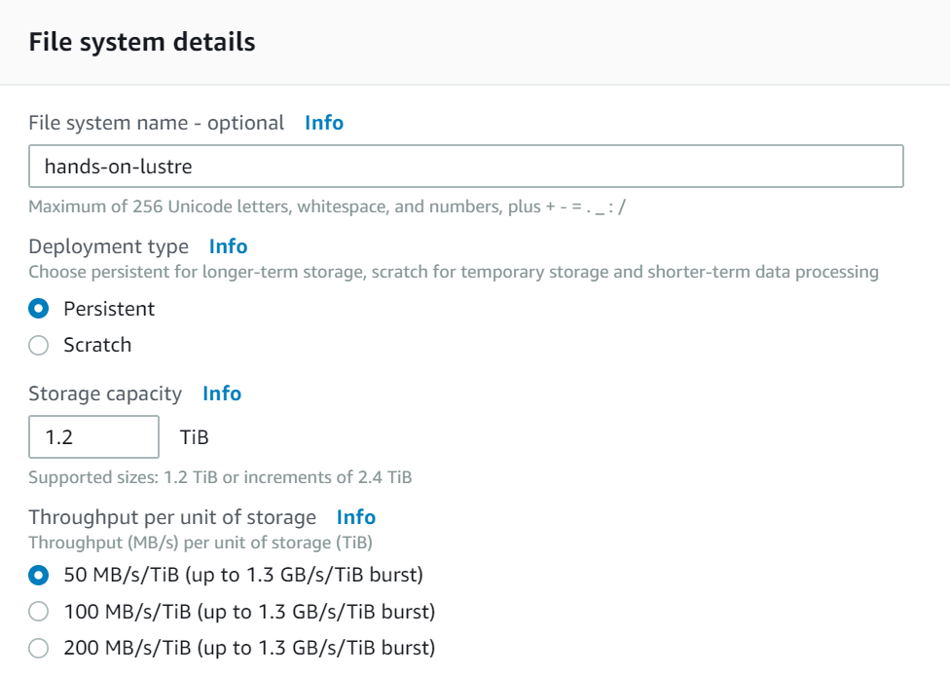

**Step 5:** Under Network & Security, the VPC security group should be the same group as your EC2 instance you created in Step 1. The security group should allow inbound traffic from TCP port 988. After that go down and click Create File System.

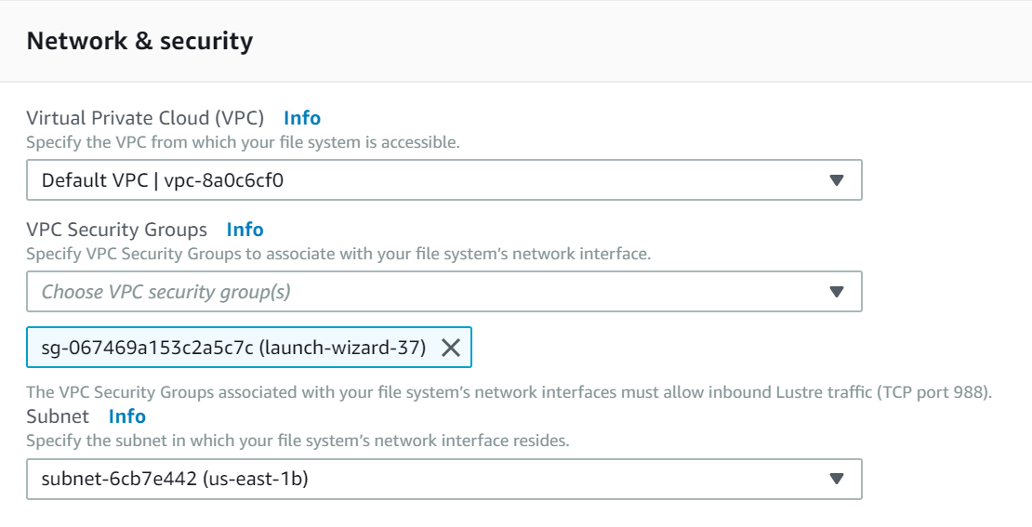

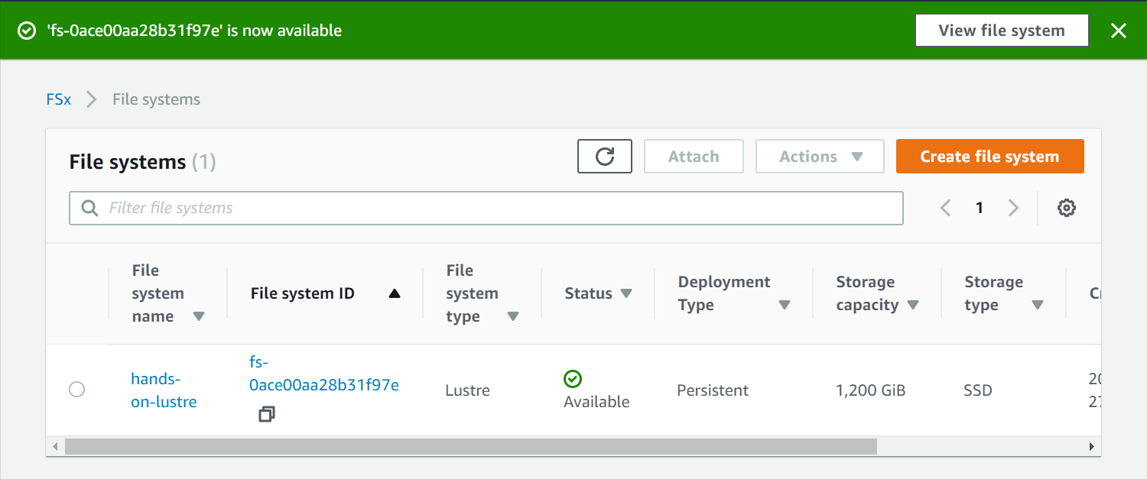

**Step 6:** Now install a Lustre client in your Linux EC2 instance using these commands.

To install -- **sudo amazon-linux-extras install -y lustre2.10**

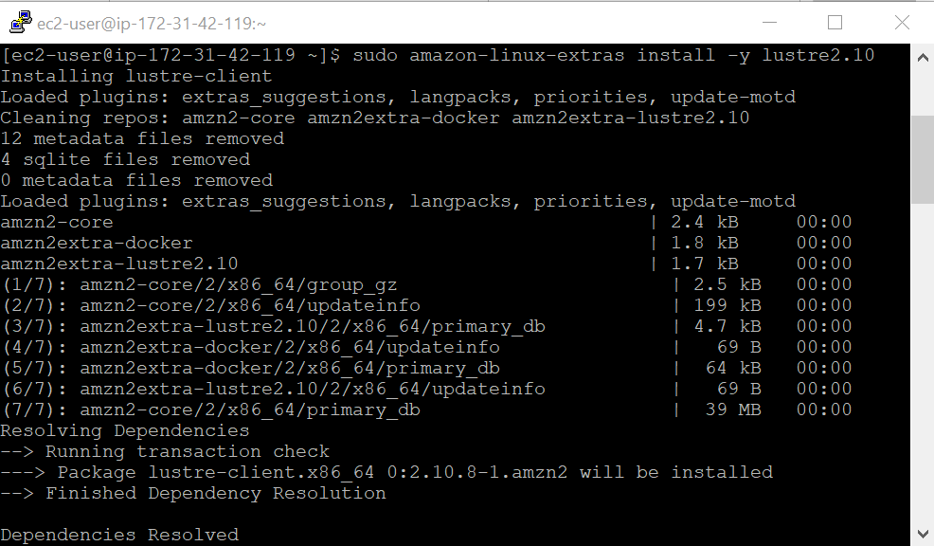

**Step 7:** Now go to the FSx console, choose the file system and click Attach button to check out the steps

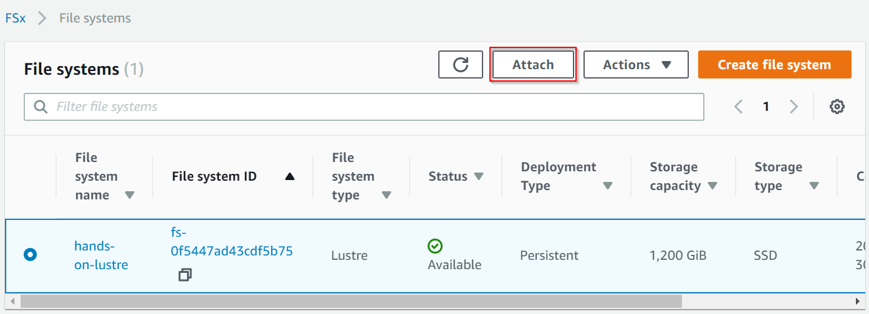

**Step 8:** Use the commands provided in the Attach file system

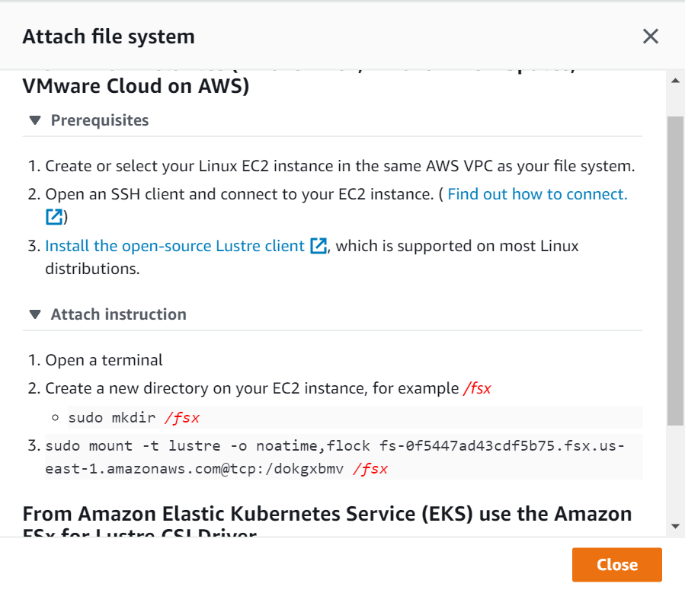

**Step 9:** Use the commands provided in the Attach file system

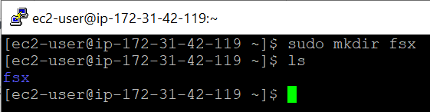

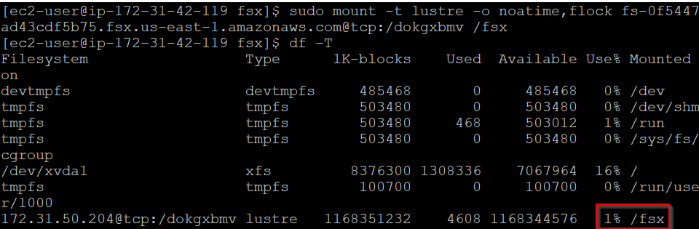

**Step 10:** We have successfully mounted the Lustre file system. Now, unmount the file system and delete it.

